Artificial Intelligence (LAB)
Lab Task no.4

Submitted by:
Rana M. Moiz Safdar
Roll Number:
SU92-BSAIM-F25-209
Class/Section:
BSAI-3D
Submitted to:
Sir Rasikh ALi

Question 1. A* (Expansion and g,h,f Value)
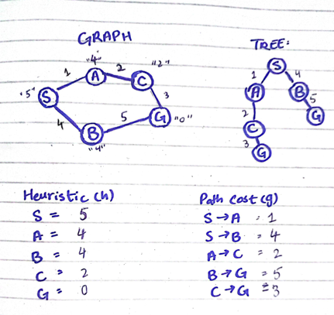

EXPANSION 1:
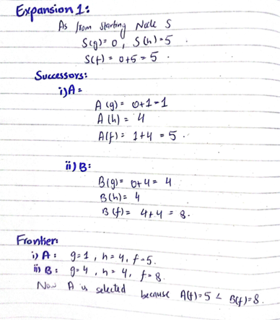

EXPANSION 2:
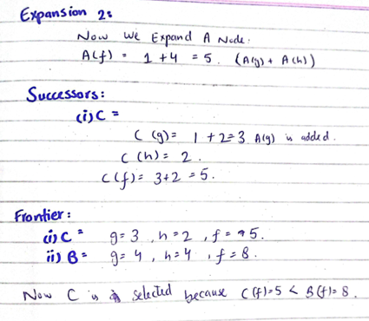

EXPANSION 3:
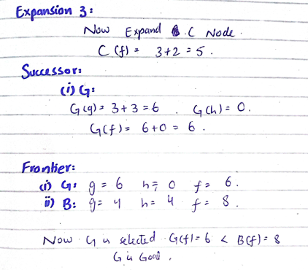

Path:
S – A – C – G
Path Cost:
1 + 2 + 3 = 6

Question 2. A* and UCS

A*:
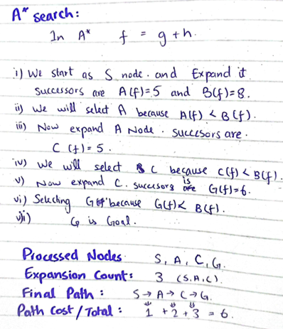

UCS:
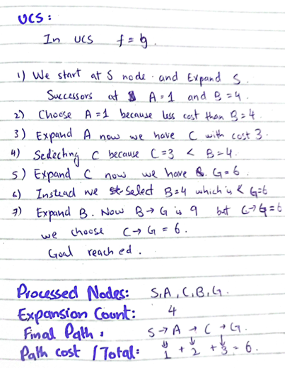

Explanation:
If we run A* and UCS on the same graph with identical weight, it would give same optimal path and same path cost only difference is, that it visited or expanded more nodes and this is because of heuristic value because in A* we calculate f = g + h and in UCS we calculate f = g. so heuristic value guided it search and resulted in less or few node expansion. So A* expanded 3 nodes while UCS expanded 4.
Question 3. Change one Heuristic value to overestimate:
Graph:
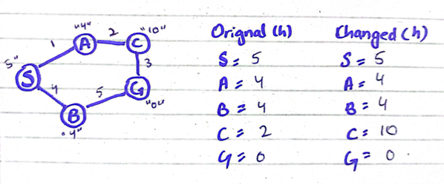

EXPANSION 1 & 2:
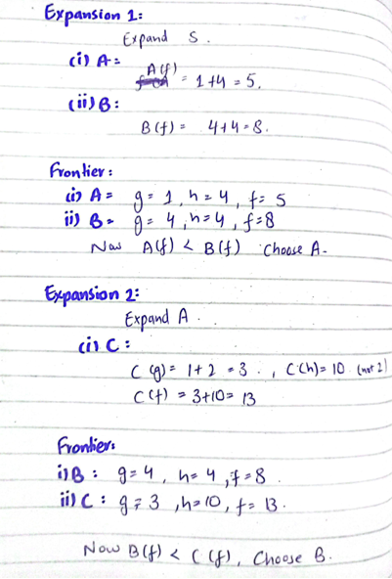

EXPANSION 3:
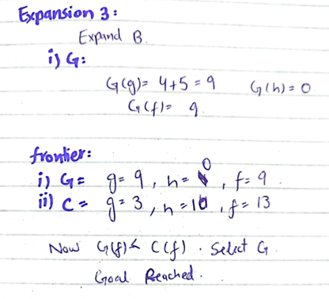

Comparison:
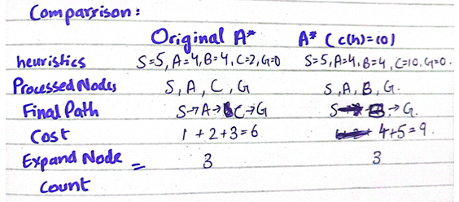

Explanation:
After we change the heuristic value to an overestimate one A* will automatically work accordingly and change its path, and as we can see the expanded node count may be same but the path cost is affected original path cost was 6 but now we have 9, this is because heuristic of C cost was overestimated this caused it to change path and choose B which isn’t optimal and more in cost.

